**Course Outcome 2**

**Submitted by : Jomin K Mathew**

**Department of MCA**

**Roll no : 122**

**Semester 1**

**Programe 1**

**Aim :** Create a HTML page to explain the use of various

predefined functions in a string and math object in java

script.

**Source code :**

***mathfunctions.html***

<html>

<head>

<title>Math Functions</title>

</head>

<body align=center>

<h3>This is good</h3>

<script>

var num=Math.abs(-2)

document.write("Absolute value :",+num);

var str="This is good";

document.write("<br>")

document.write("char at 0 is:"+str.charAt(0));

document.write("<br>Index of good :"+str.indexOf("good"));

var c=45.20

var x=Math.ceil(c)

document.write("<br>Ceil value of no is :"+x);

var lw="this is this";

document.write("<br>To upper :"+str.toUpperCase(lw));

var power=Math.pow(2,2);

document.write("<br> Power of the given number is :"+power);

</script>

</body>

</html>

**Output :**

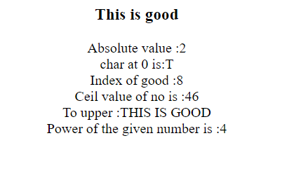

**Program 2**

**Aim :** Generate the calendar using JavaScript code by getting

the year from the user.

**Source code :**

***calender.html***

<html>

<head>

<body align=center>

<script language="javascript">

function day_title(day_name)

{

document.write("<td align=center width=30 bgcolor=grey><b>"+day_name+"</b></td>");

}

function fill_table(month,month_len)

{

day=1;

document.write("<table border=1 cellspacing=2 cellpadding=3%>");

document.write("<td colspan=7 align=center ><b>"+month+" "+year+"</b><tr>");

day_title("SUN");

day_title("MON");

day_title("TUE");

day_title("WED");

day_title("THU");

day_title("FRI");

day_title("SAT");

document.write("</tr><tr>");

for(var i=1; i<start_day;i++)

{

document.write("<td>");

}

for(var i=start_day; i<8;i++)

{

document.write("<td align=center bgcolor=>"+day+"</td>");

day++;

}

document.write("<tr>");

while(day<=month_len)

{

for(var i=1; i<=7 && day<=month_len;i++)

{

document.write("<td align=center bgcolor=>"+day+"</td>");

day++;

}

document.write("<tr>");

start_day=i;

}

document.write("</tr></table><br>");

}

year=prompt("Enter The Year ",2021);

today=new Date("January 1, "+year);

start_day=today.getDay()+1;

fill_table("January", 31);

if (year%4==0)

fill_table("February", 29);

else

fill_table("February", 28);

fill_table("March", 31);

fill_table("April", 30);

fill_table("May", 31);

fill_table("June", 30);

fill_table("July", 31);

fill_table("August", 31);

fill_table("September", 30);

fill_table("October", 31);

fill_table("November", 30);

fill_table("December", 31);

</script>

</body>

</head>

</html>

**Output :**

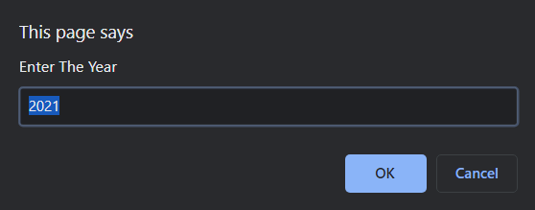

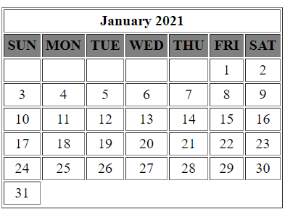

**Program 3**

**Aim :** Create a HTML registration form and to validate the

form using JavaScript code.

**Source code :**

***validate.html***

<!DOCTYPE html>

<html lang="en" dir="ltr">

<head>

<meta charset="utf-8">

<title>Login</title>

<script>

function registration()

{

var name = document.forms["reg"]["name"];

var pass = document.forms["reg"]["pass"];

var submit=document.forms["reg"]["sub"]

if (name.value == "")

{

window.alert("Please enter your Username");

name.focus();

return false;

}

if (pass.value == "")

{

window.alert("Please enter your Password");

pass.focus();

return false;

}

if (pass.value && name.value)

{

window.alert("Succesfully Logined");

sub.focus();

return false;

}

return true;

}

</script>

<link rel="stylesheet" href="style.css">

</head>

<body class=bg>

<form name="reg" onsubmit="return registration()" class="box" action="Validate.html" method="post" >

<h1>Login</h1>

<input type="text" name="name" placeholder="Username">

<input type="password" name="pass" placeholder="Password">

<input type="submit" name="sub" value="Login">

</form>

</body>

</html>

***style.css***

body{

margin: 0;

padding: 0;

font-family: sans-serif;

background: #34495e;

}

.box{

width: 300px;

padding: 40px;

position: absolute;

top: 50%;

left: 50%;

transform: translate(-50%,-50%);

background: #191919;

text-align: center;

}

.box h1{

color: white;

text-transform: uppercase;

font-weight: 500;

}

.box input[type = "text"],.box input[type = "password"]{

border:0;

background: none;

display: block;

margin: 20px auto;

text-align: center;

border: 2px solid #3498db;

padding: 14px 10px;

width: 200px;

outline: none;

color: white;

border-radius: 24px;

transition: 0.25s;

}

.box input[type = "text"]:focus,.box input[type = "password"]:focus{

width: 280px;

border-color: #2ecc71;

}

.box input[type = "submit"]{

border:0;

background: none;

display: block;

margin: 20px auto;

text-align: center;

border: 2px solid #2ecc71;

padding: 14px 40px;

outline: none;

color: white;

border-radius: 24px;

transition: 0.25s;

cursor: pointer;

}

.box input[type = "submit"]:hover{

background: #2ecc71;

}

**Output :**

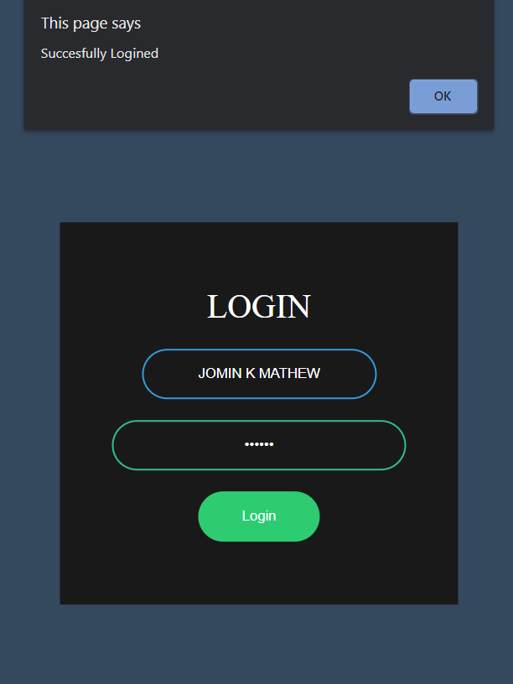 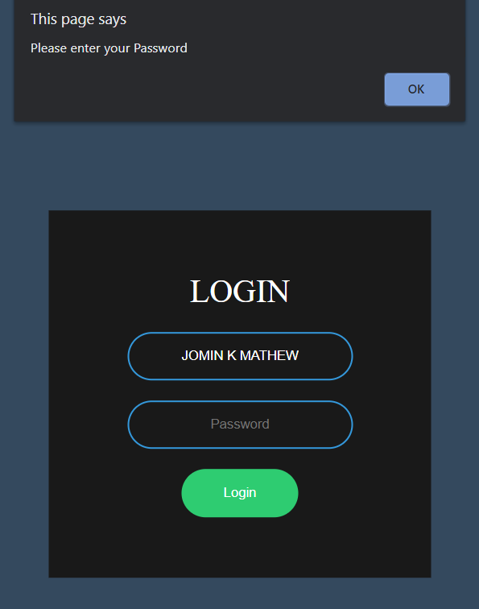

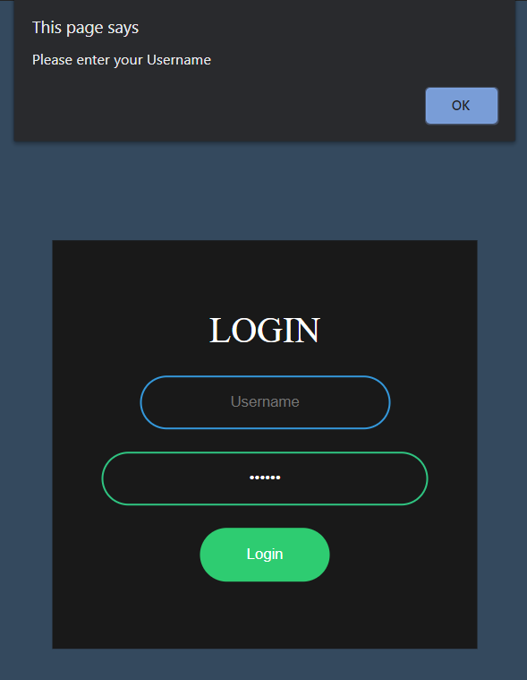

**Program 4**

**Aim :** Evaluating JavaScript Event Handling for every click

of a button to change the background color of a HTML

page.

**Source code :**

***bg color change.html***

<!DOCTYPE html>

<html>

<body align="center">

<h1 align="center">Color</h1>

<button type="button" onclick="myFunction()">Click here</button>

<script>

function myFunction()

{

document.body.style.backgroundColor = "red";

}

</script>

<button type="button" onclick="myFunction1()">Click here</button>

<script>

function myFunction1()

{

document.body.style.backgroundColor = "blue";

}

</script>

<button type="button" onclick="myFunction2()">Click here</button>

<script>

function myFunction2()

{

document.body.style.backgroundColor = "green";

}

</script>

<button type="button" onclick="myFunction3()">Reset</button>

<script>

function myFunction3()

{

document.body.style.backgroundColor = "white";

}

</script>

</body>

</html>

**Output :**

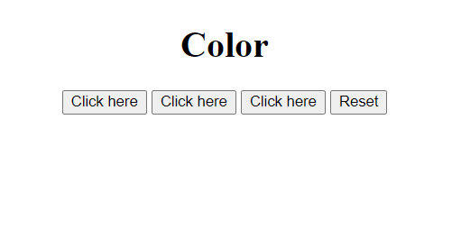

**Program 5**

**Aim :** Create a HTML page to display a new image and text

when the mouse comes over the existing content in the

page using JavaScript Event Handling.

**Source code :**

***mouse.html***

<html>

<head>

<script language="javascript">

function preload()

{

topon=new Image(30,30);

topon.src="1.png";

topoff=new Image(260,280);

topoff.src="2.png";

}

function myMouseOn(n)

{

preload();

imageON=eval(n+"on.src");

document.images[n].src=imageON;

}

function myMouseOff(n)

{

imageOFF=eval(n+"off.src");

document.images[n].src=imageOFF;

}

</script>

</head>

<body align=center>

<br><br>

<h1> Demo for mouse over</h1>

<a href="#" onMouseOut="myMouseOff('top')"; onMouseOver="myMouseOn('top')";>

<img src="Koala.jpg" alt="Show Next" name="top">

</a>

</body>

</html>

**Output :**

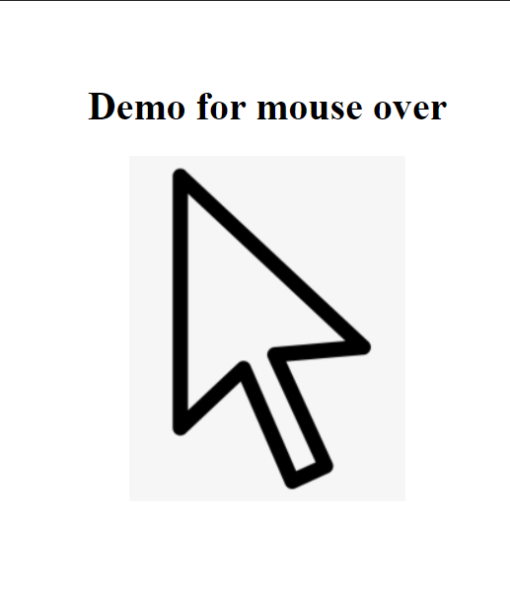

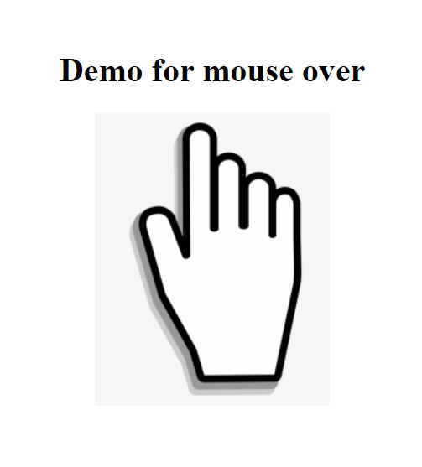

**Program 6**

**Aim :** Create a HTML page to show online exam using

JavaScript.

**Source code :**

***online exam.html***

<html>

<head>

<title>online exam</title>

<script language="javascript">

function exam(form)

{

var i=0;

if(form.one[3].checked)

i=i+1;

if(form.three[1].checked)

i=i+1;

window.alert("Your Score is: "+i);

}

</script>

</head>

<body align=center bgcolor=white>

<form onSubmit="exam(this)">

<br><br>

<center><h1><blink>Online Examination</blink></h1></center>

<p> <br>

<h1>1)Who is the father of c</h1>

<input type="radio" name="one" value="">

<label>Rob Pike</label>

<input type="radio" name="one" value="">

<label>Bjarne Stroustrup</label>

<input type="radio" name="one" value="">

<label>Brian Kernighan</label>

<input type="radio" name="one"value="">

<label>Dennis Ritchie</label>

</p>

<p>

<h1>2) Who is the father of c++</h1>

<input type="radio" name="three" value="">

<label>Dennis Ritchie</label>

<input type="radio" name="three" value="">

<label>Bjarne Stroustrup</label>

<input type="radio" name="three" value="">

<label>Rob Pike</label>

<input type="radio" name="three" value="">

<label>Brian Kernighan</label> </p>

<p><center>

<br>

<input type="submit" value="Submit">

<input type ="reset" value="Reset">

</center></p>

</body>

</html>

**Output :**

